Test report #2

Environment description

OS: Windows 11
Interpreter: Python 3.13
Version: Git hash c23eefcb (16.06.2026)

System test scenarios

Scenario #0: Standard usage

The application works as expected when using as intended. The prompt leave no doubt how to use the application. Tables are clear, readable and properly formatted. CSV export works as expected and API calls successfully download the historical data.

Scenario #1: Not exact user inputs

The application recognizes user input when it’s capitalization is different than specified, but does not when there’s an extra whitespace character in the input („ USD”, „USD ”, etc.).

Scenario #2: Invalid input types

The application did not throw any unhandled errors when attempting to specify: Non-listed currencies, text in number inputs, floats in integer inputs, empty inputs in all fields, indicies out of range and negative integers.

Date input from change distribution incorrectly identifies dates in the future as being too far in the past (For example: 31.12.2099). This is caused by the „start_date > min_date” check using the wrong sign also making the next check of „start_date > today” unreachable. As a consequence inputting a date too early returns a No data found error (An error occurred: No data found for currency 'USD'. Check the currency code (e.g., USD, EUR, CHF).)

Scenario #3: Repeated analysis

When performing repeated analysis and exporting them no critical bugs were found. The only problem that might happen is that exporting results to a .csv file causes it to overwrite the previous one without asking or warning the user.

Scenario #4: Edge-case inputs

The app correctly prevents the user from comparing the currency to itself even when the inputs differ in capitalization.
When performing change distribution analysis and inputting an invalid currency, PLN disappears from the list of available currencies and cannot be chosen.

Scenario #5: No write permission

When the app has no write permissions and the user requests to download the table as .csv a raw error gets printed: An error occurred: [Errno 13] Permission denied: 'export_SESSION_ANALYSIS.csv'

Other Bugs

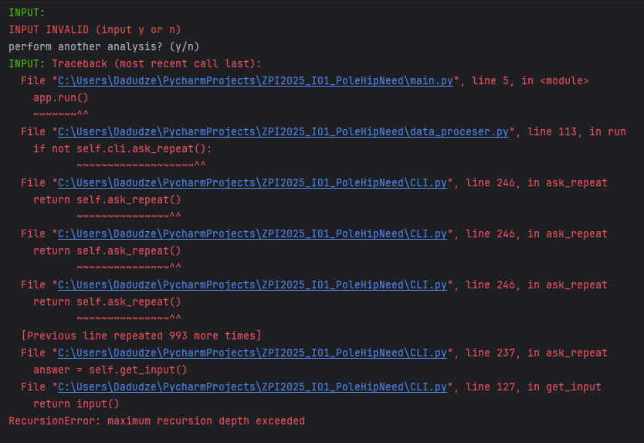
Bug #1 (Low Severity):
Recursive input

User reprompting for valid input happens recursively risking stack overflows.

Can be reproduced by holding enter
in any of the input prompts.

Retesting.

- The 0-division error in calculate_change_distribution has been fixed
- The naming-convention bugs have not yet been fixed.
- Redundant variable declarations have not yet been removed.

Summary of found defects

- Inputs are not trimmed by whitespace.
- The start_date > min_date CLI.py:295 is misleading as it checks for the max date.
- This check apparently fooled the developers into adding wrong error messages, adding an always false check (start_date > today) and skipping the real start_date < min_date check.
- Lack of overwrite warnings / confirmations.
- Improperly handled csv write errors.
- Input errors are handled recursively.

